**IBM ASSIGNMENT-1 HOME AUTOMATION**

**CIRCUIT DIAGRAM:**

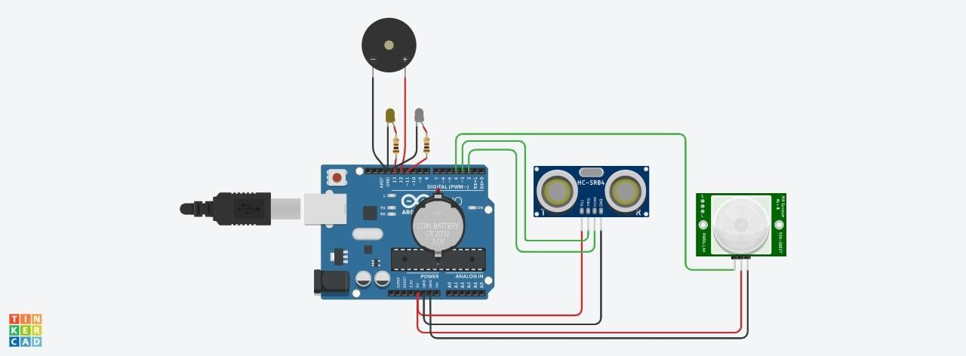

**CODE:**

void setup()

{

pinMode(11, OUTPUT); pinMode(12, OUTPUT); pinMode(13,OUTPUT); pinMode(2,INPUT); pinMode(3, OUTPUT); pinMode(4,INPUT);

Serial.begin(1000);

}

void loop()

{

int a=digitalRead(4);

//Reads the motion in the room.

//------------------------------------------ if(a) {

digitalWrite(11,HIGH);

//if moment is detected the light will glow for 5 minutes. delay(5000);//5 minutes is taken as 5 seconds.

Serial.println("\n\nmotion in the room,lights is ON");

}

else

{

digitalWrite(11,LOW);

//if there is no motion after 5 minutes the light turns off .

Serial.println("\n\nNo motion,light is OFF");

}

//-------------------------------------------------------

digitalWrite(3,LOW);//no gen. of pulse of sound digitalWrite(3,HIGH);//gen, of pulse of sound delayMicroseconds(5);//10ms of sound pulse. digitalWrite(3,LOW);//ultrasonic sensor is off. float p=pulseIn(2,HIGH);//receives the reflected signal. float d=(p*0.0343)/2;//calculate distance of the water level.; if(d<50)

{

tone(12,500);//the water tank is full is indicated //using a buzzer.

Serial.println("\n\nThe Water Tank is full");

}

else if (d>250)

{

noTone(12); digitalWrite(13,HIGH);//if the water tank is empty,yellow

//light gets on indicating tank is empty.

Serial.println("\n\nThe Water Tank is empty");

}

else

{

noTone(12); digitalWrite(13,LOW);//the water level is normal.

Serial.println("\n\nThere is Water in the water Tank");

}

}

**TINKERCAD LINK:**

[https://www.tinkercad.com/things/fRqDDMudAqp-assignment-](https://www.tinkercad.com/things/fRqDDMudAqp-assignment-1/editel?sharecode=9EKlMaKBkcvSSyoZORscH5ohvNBUAFUD37NUus87H-c)

[1/editel?sharecode=9EKlMaKBkcvSSyoZORscH5ohvNBUAFUD37NUus87H-c](https://www.tinkercad.com/things/fRqDDMudAqp-assignment-1/editel?sharecode=9EKlMaKBkcvSSyoZORscH5ohvNBUAFUD37NUus87H-c)

**OUTPUT:**

